220MHz DUAL EXPOSED DIPOLE | 215-225 MHz
(2)871F702HBSP4DF1/2
The (2)871F702HBSP4DF1/2 is a Wide Band, Welded, Heavy Duty, Black Anodized, Low PIM dual antenna designed for multicoupled systems. Our antennas can be adjustable, or fixed, side mount or top mount. This antenna has internal cabling and is not field adjustable, it is configured for side mount.
- The (2)871F702HBSP4DF1/2 has internal cabling and fixed dipole-mast spacing.
- This antenna is ½ wave length spacing offering bi-directional radiation pattern.
- This antenna is available in Low-PIM (-150 dBc; two 20W carriers).
(2)871F702HBSP4DF1/2
Electrical Specifications | (2)871F702HBSP4DF1/2
Frequency Range, MHz | 215-225
Nominal Gain, dBd | 2.0-2.5
Number of Dipoles | 2
Isolation, dB | 40
Bandwidth 1.5:1 VSWR, MHz | 10
Polarization | Vertical  Vertical
Pattern | Bi-directional
Power Rating, Watts | 200
Nominal Impedance, Ohms | 50
Lightning Protection | DC Ground
PIM | 150 dBc; 2 x 20W carriers
Standard Termination | Dual Feed Terminating in Type 7/16 DIN Female
Mechanical Specifications | (2)871F702HBSP4DF1/2
Length, in (mm) | 150 (3810)
Width (1/2 Wave Spacing), in (mm) | 34 (864)
Weight, lbs. (kg) | 30 (13,6)
Rated Wind Velocity, No Ice, mph (km/h) | 150 (241)
Rated Wind Velocity, 0.5” (13mm) ice, mph (km/h) | 130 (209)
Lateral Thrust @ 100 mph, wind, lbs. (kg) | 98 (436,4)
Bending Moment @ top clamp: 100 mph, ft.*lb (kg*m) | 299 (406)
Projected Area, ft² (m²) | 3,8 (0.35)
Mounting Information Mast O.D. (mm) | 2.4" (61)
Space between clamp, in (mm) | 24” (610)
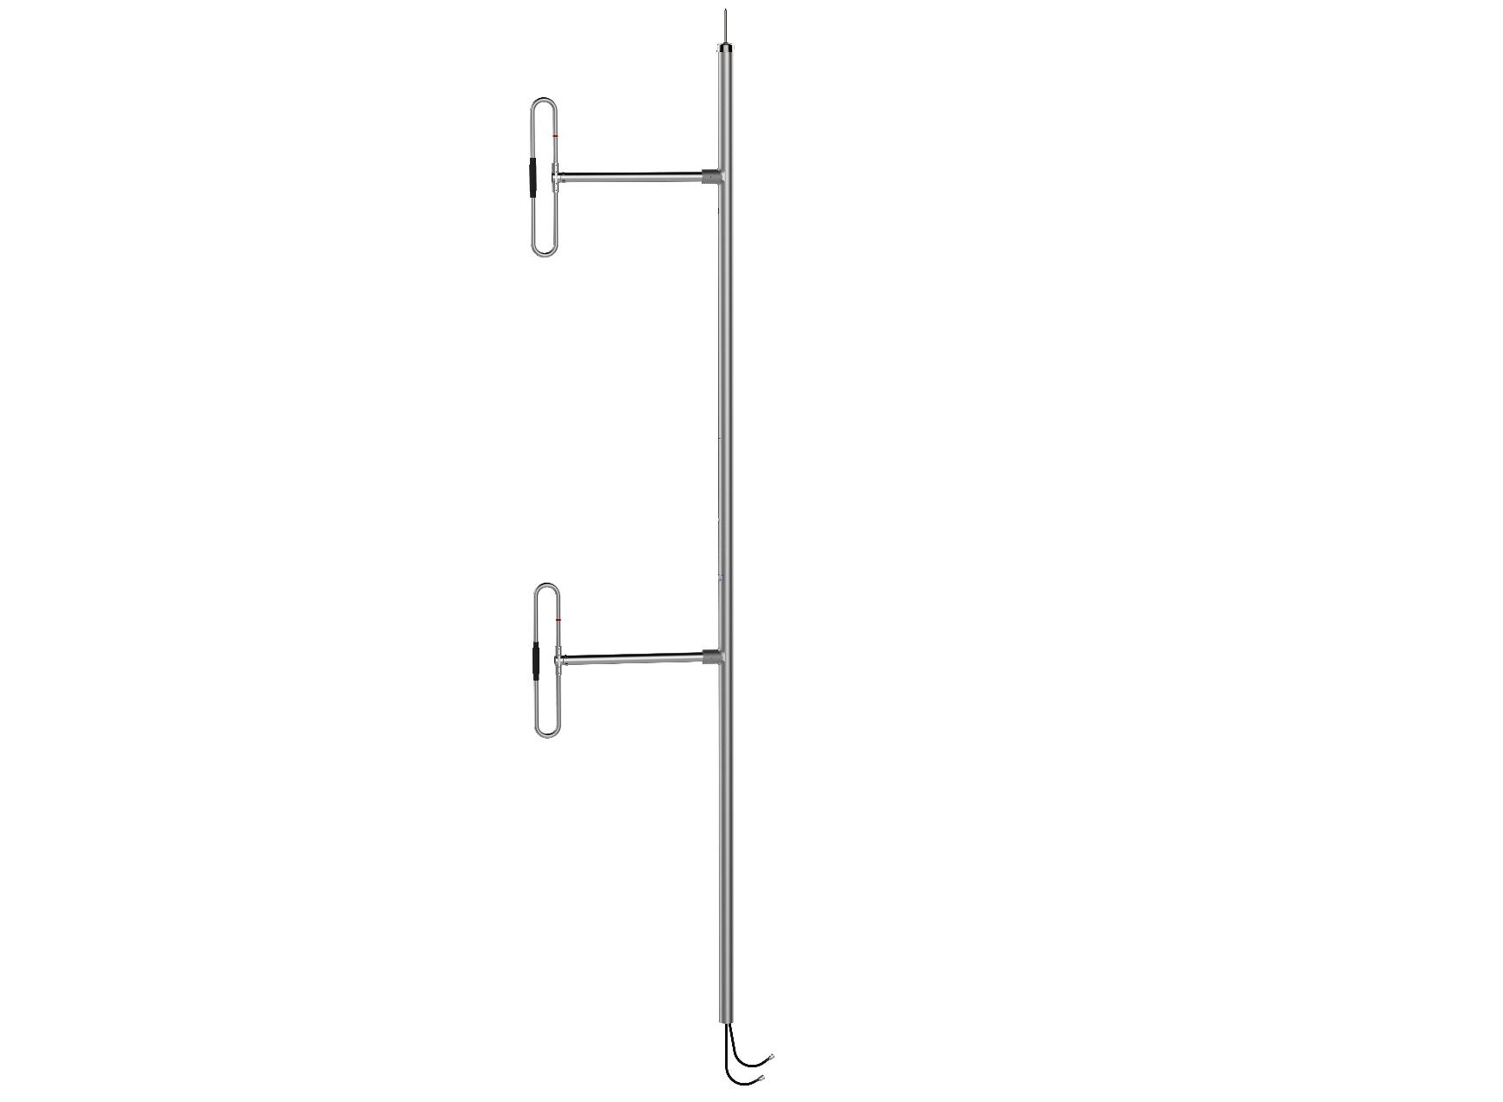
220MHz DUAL EXPOSED DIPOLE | 215-225 MHz

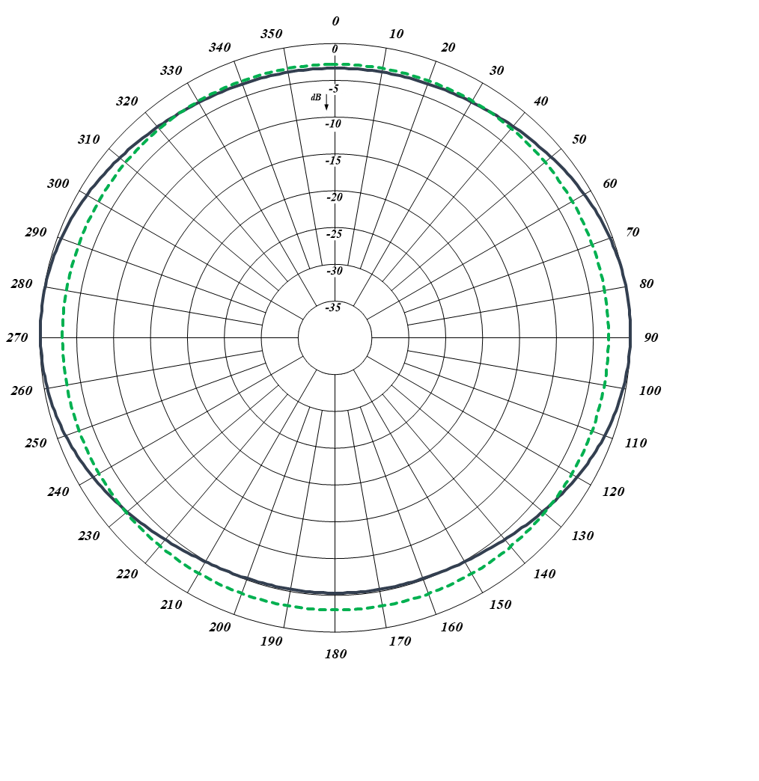

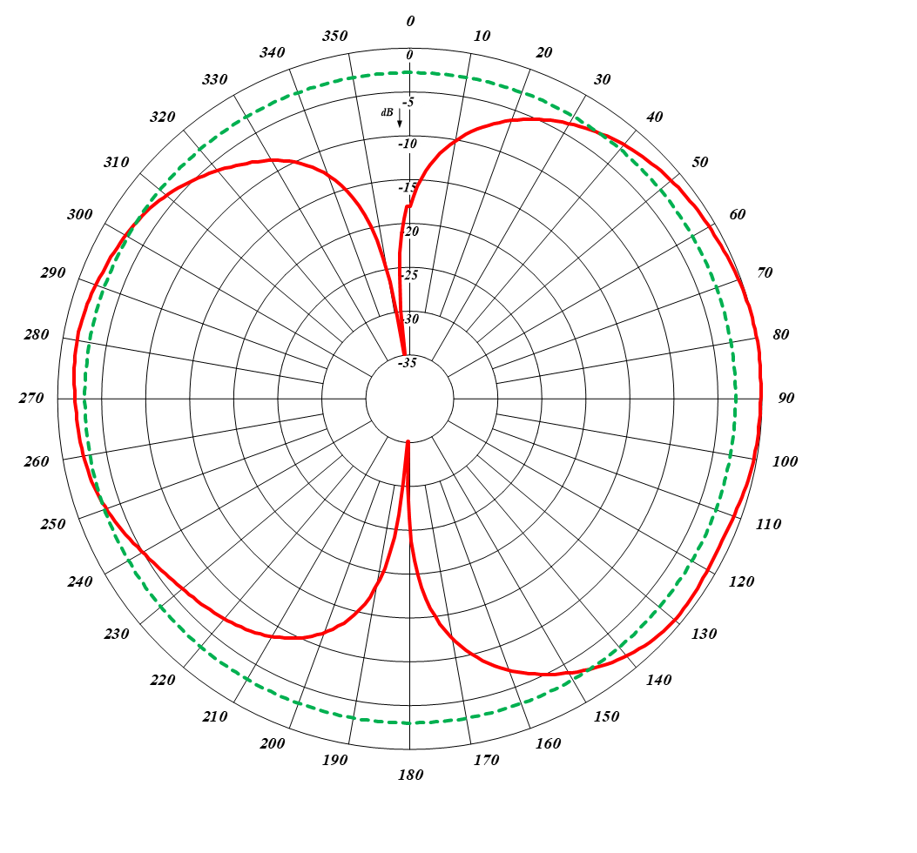
Half-wave Spacing Vertical
Half-wave Spacing Horizontal

