UHF CORNER REFLECTOR | 380-430 MHz
440-70-HDBP*3
The 440-70-HDBP*3 is Heavy Duty, Black Anodized, Low PIM Corner Reflector Antenna. This antenna has a very high front-to-back ratio. It is broadband and is ideal for point-to-point applications. Performance is constant throughout the band. The antenna has a rugged design to withstand harsh environmental conditions.

- The mounting hardware supplied will permit either vertical or horizontal polarization
- DC ground for lightning protection
Electrical Specifications | 440-70-HDBP*3
Frequency Range, MHz (in splits) | 380-430
Nominal Gain, dBd | 9.5
Bandwidth: 1.5:1 VSWR, MHz | 50
Polarization | Vertical or horizontal
Horizontal Beamwidth (Vert. Pol.) | 60º
Vertical Beamwidth (Vert. Pol.) | 45º
Front to Back, dB | 25
Pattern | Directional
Power Rating, Watts | 100
Nominal Impedance, Ohms | 50
PIM | 150 dBc; 2 x 20W carriers
Lightning Protection | DC Ground
Standard Termination | DIN 7/16 male, 4.3/10 available upon request
Mechanical Specifications | 440-70-HDBP*3
Length, in (mm) | 30 (762)
Width, in (mm) | 50 (1270)
Weight, lbs. (kg) | 36 (16)
Rated Wind Velocity, No Ice, mph (km/h) | 135 (217)
Rated Wind Velocity, 0.5” (13mm) ice, mph (km/h) | 95 (153)
Lateral Thrust @ 100 mph, wind, lbs. (kg) | 210 (934)
Projected Area, ft² (m²) | 3.6 (0.34)
Mounting Hardware Included | 172-85 Clamp

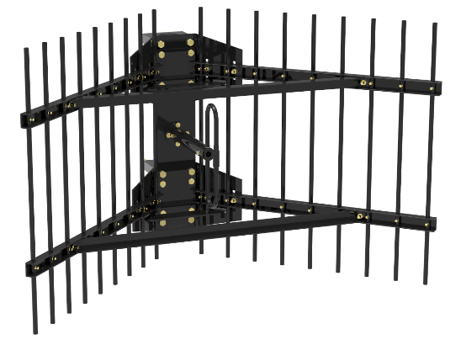

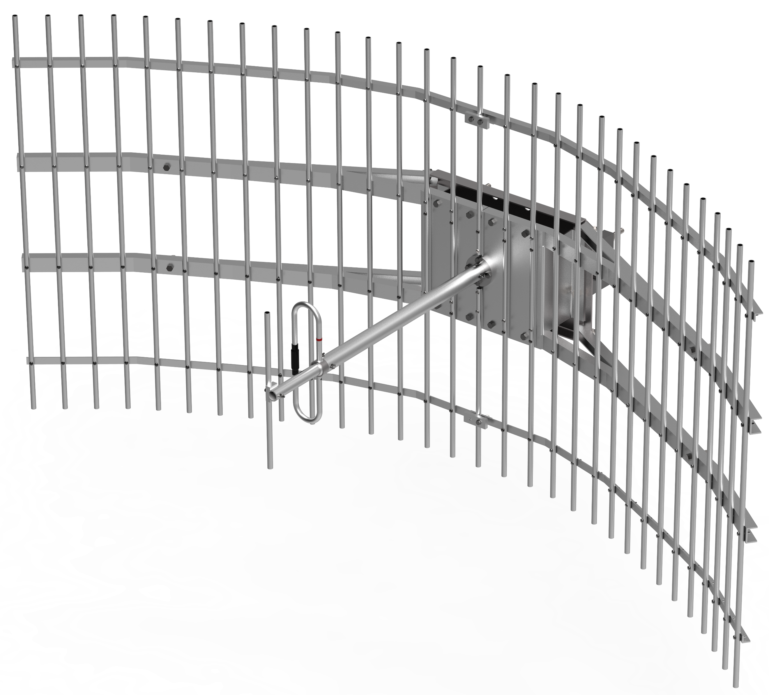
440-70-HDBP*3
UHF CORNER REFLECTOR | 380-430 MHz
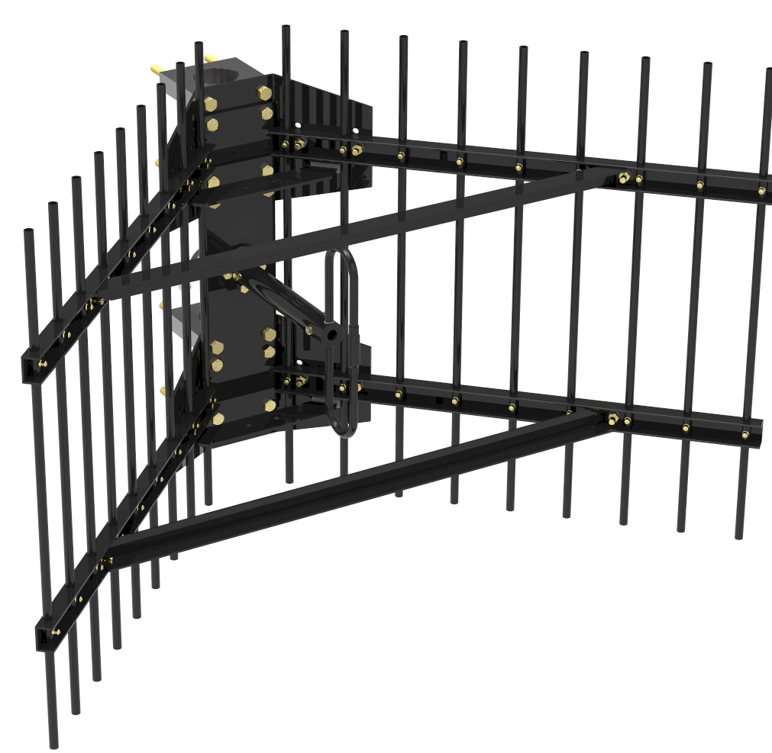
440-70-HDBP*3

440-70

