VHF EXPOSED DIPOLES | 138-174 MHz
F-33030-D
The F-33030-D is a Wide Band Omnidirectional Antenna specifically designed for trunked multicoupled and X-pass systems applications. This antenna is extremely rugged and is well suited for use in severe environmental conditions. This antenna is a Low Intermod design that incorporates a minimum of moveable joints in its construction and replaces standard castings with heavy duty welded joints.

- The F-33030-D has internal cabling design and is not field adjustable.
- Passive Intermodulation Specification is measured in the third order intermodulation products, using two 25 watts (+44 dBm) Carriers.
Electrical Specifications | F-33030-D
Frequency Range, MHz | 138-174
Nominal Gain, dBd | 6
Number of Dipoles | 8
Bandwidth 1.5:1 VSWR, MHz | 36
Polarization | Vertical
Pattern | Omni
Power Rating, Watts | 500
Nominal Impedance, Ohms | 50
Lightning Protection | DC Ground
Passive Intermodulation | -107 dBm (-150 dBc)
Standard Termination | 7/16 DIN male connector attached to end of 118 in (3000 mm) RG-214 Cable
Mechanical Specifications | F-33030-D
Length, in (mm) | 246 (6248)
Width (1/2 Wave Spacing), in (mm) | 30 (762)
Weight, lbs. (kg) | 130 (59)
Lateral Thrust lb (N) | 297 (1319)
Bending moment at top clamp lb-ft (N-m) | 2107 (2857)
Wind Zone | 1000 Pa
Material | Aluminum 6061-T6
Projected Area, ft² (m²) | 11,1 (1,03)
Mounting Information Mast O.D. (mm) | Mast 4,5" (114.3 mm) O.D.
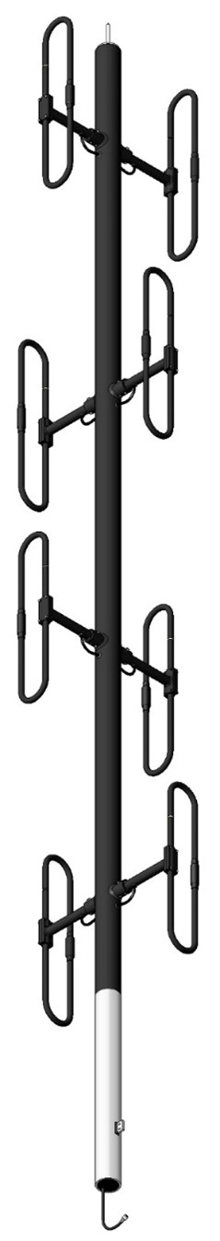

VHF EXPOSED DIPOLE | 138-174 MHz
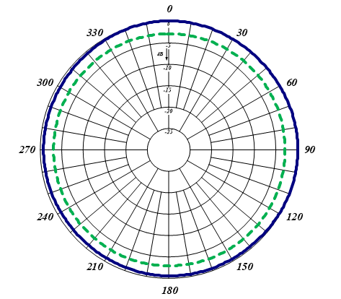

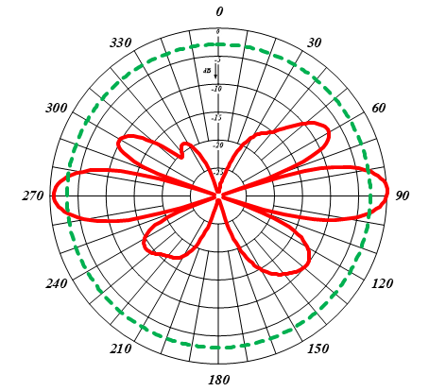
Horizontal (Azimuth) Radiation Pattern
Vertical (Elevation) Radiation Pattern

