VHF EXPOSED DIPOLES | 138-174 MHz
F-33031-D
The F-33031-D is a Wide Band Omnidirectional Antenna specifically designed for trunked multicoupled and X-pass systems applications. This antenna is extremely rugged and is well suited for use in severe environmental conditions. This antenna is a Low Intermod design that incorporates a minimum of moveable joints in its construction and replaces standard castings with heavy duty welded joints.

- The F-33031-D has internal cabling design and is not field adjustable.
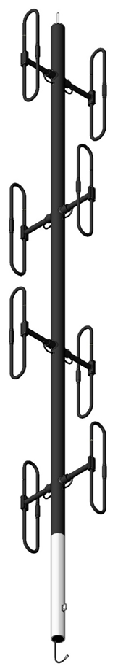
- Passive Intermodulation Specification is measured in the third order intermodulation products, using two 25 watts (+44 dBm) Carriers.
Electrical Specifications | F-33031-D
Frequency Range, MHz | 138-174
Nominal Gain, dBd | 6
Number of Dipoles | 8
Bandwidth 1.5:1 VSWR, MHz | 36
Polarization | Vertical
Pattern | Omni
Power Rating, Watts | 500
Nominal Impedance, Ohms | 50
Lightning Protection | DC Ground
Passive Intermodulation | -107 dBm (-150 dBc)
Standard Termination | 7/16 DIN male connector attached to end of 118 in (3000 mm) RG-214 Cable
Mechanical Specifications | F-33031-D
Length, in (mm) | 246 (6248)
Width (1/2 Wave Spacing), in (mm) | 30 (762)
Weight, lbs. (kg) | 140 (63.5)
Weight with 1,57" (40mm) ice, lbs (kg) | 604 (274)
Lateral Thrust lb (N) | 665 (2955)
Bending moment at top clamp lb-ft (N-m) | 4891 (6637)
Wind Zone | 600 Pa
Material | Aluminum 6061-T6
Projected Area, ft² (m²) | 11,1 (1,03)
Mounting Information Mast O.D. (mm) | Mast 3,5" (88.9 mm) O.D.
VHF EXPOSED DIPOLE | 138-174 MHz
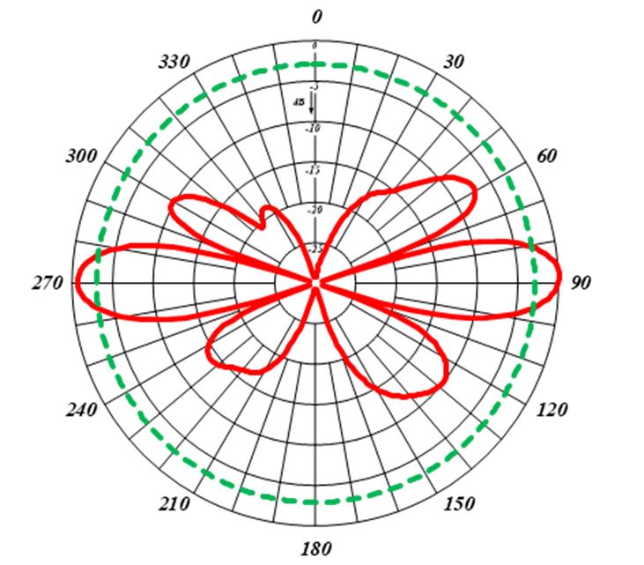
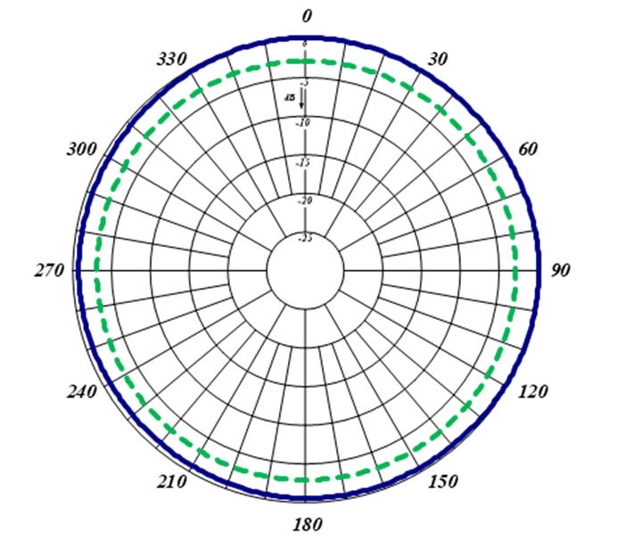
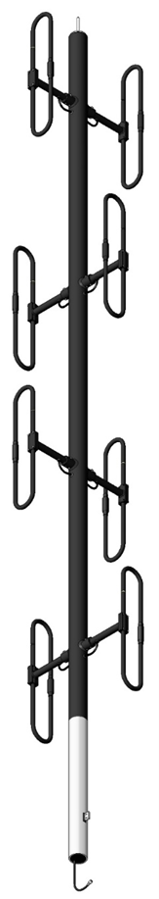
Horizontal (Azimuth) Radiation Pattern

Vertical (Elevation) Radiation Pattern

