PUBLIC SAFETY COLLINEAR OMNI ANTENNA 746-869 MHz

927-70-7.0-43F
The Null Fill is optional, the Down tilt degrees available from 1 to 10 in one degree increment.
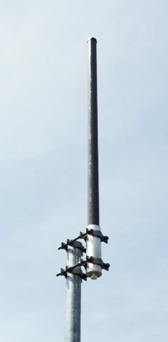
Electrical Specifications | 927-70-7.0-43F
Frequency Range | 740-870 MHz
Gain | 7.0 dBd
VSWR (Return Loss) | <1.5:1 (14dB)
Passive IM 3rd Order (2x20W) | -150 dBc
Peak Instantaneous Power (PIP) | 25 kW
Power Input | 500 W
Vertical Beamwidth | 12°
Horizontal Beamwidth | Omni +/-0.25 dB
Input | 4.3-10 Female
Beam Tilt | 0-10 degree options
Mechanical Specifications | 927-70-7.0-43F
Configuration |  | Corporate Fed Dipole Array
Length |  | 84”
Radome Diameter |  | 2.5”
Weight |  | 18 lbs
Shipping Weight |  | 26 lbs
Shipping Dimensions | L | 86”
 | W | 4”
 | H | 4”
Mounting Area |  | 12.0” x 3.0” diam. aluminum

PUBLIC SAFETY COLLINEAR OMNI ANTENNA 740-870 MHz
Environmental Specifications 927-70-7.0-43F
927-70-7.0-43F

927-70-7.0-43F

927-70-7.0-43F

IP Rating 66
Projected Area 0.88 ft2 (no ice)
1.21 ft2 (with ice)
Lateral Thrust @ 100mph 35 lbs.
Wind Gust Rating 150 mph

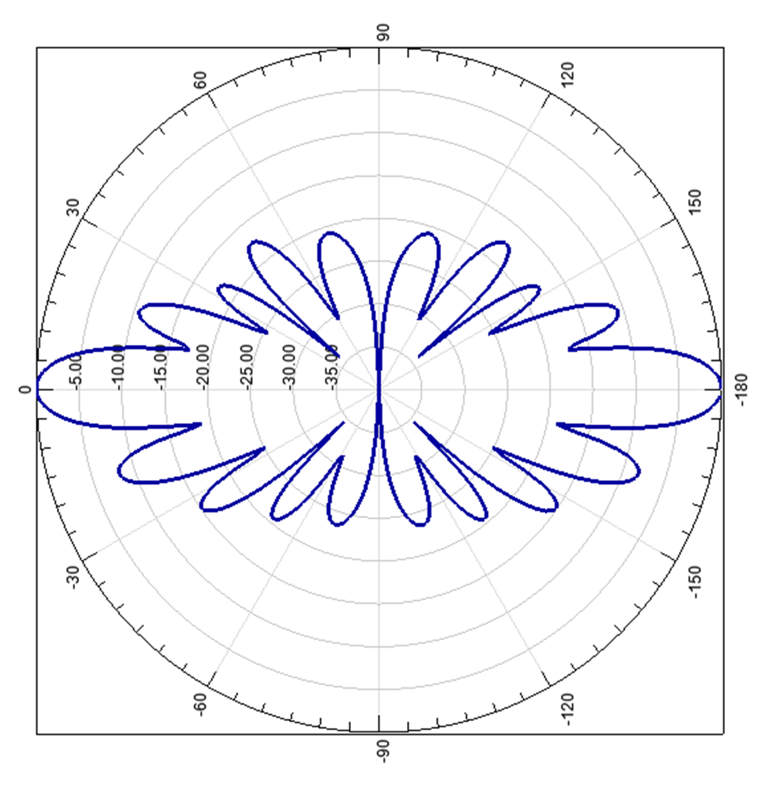

Standard Elevation Pattern

PUBLIC SAFETY COLLINEAR OMNI ANTENNA 740-870 MHz

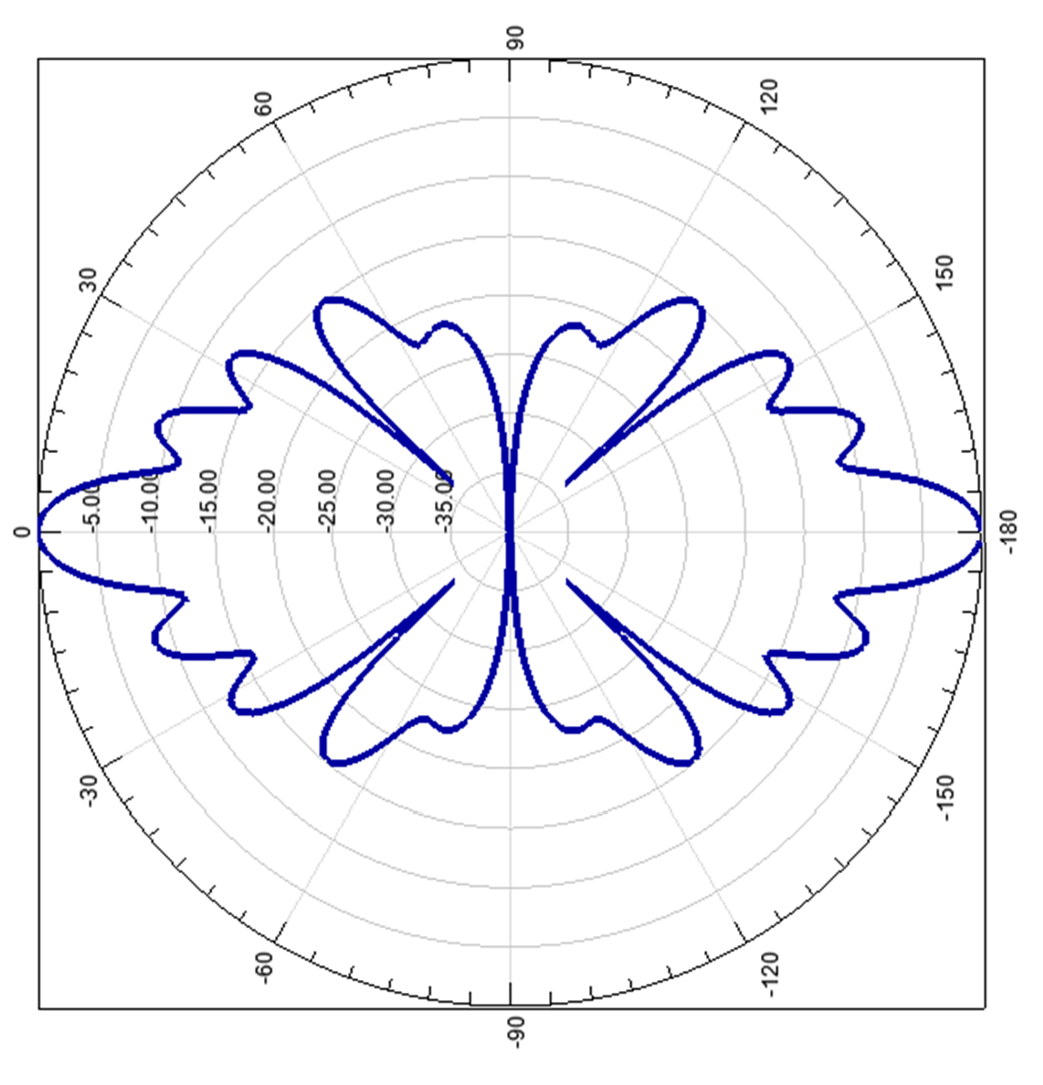

Null Fill

