PUBLIC SAFETY COLLINEAR OMNI ANTENNA 740-870 MHz

929-70-10.0-43F
The Null Fill is optional, the Down tilt degrees available from 1 to 10 in one degree increment.
PUBLIC SAFETY COLLINEAR OMNI ANTENNA 740-870 MHz
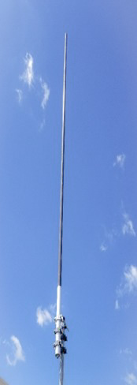
Electrical Specifications | 929-70-10.0-43F
Frequency Range | 870-970 MHz
Gain | 10 dBd
VSWR (Return Loss) | <1.5:1 (14dB)
Passive IM 3rd Order (2x20W) | -150 dBc
Peak Instantaneous Power (PIP) | 25 kW
Power Input | 400 W
Vertical Beamwidth | 6°
Horizontal Beamwidth | Omni +/-0.5 dB
Input | 4.3-10 Female
Beam Tilt | 0-10 degree options

Mechanical Specifications 929-70-10.0-43F
Configuration |  | Corporate Feed PC Dipole
Length |  | 150”
Radome Diameter |  | 2”
Weight |  | 25 lbs
Shipping Weight |  | 39 lbs
Shipping Dimensions | L W H | 152”  4”  4”
Mounting Area |  | 12.0” x 2.5” diam. aluminum
Suggested Clamps (not included) |  | 112-85

Environmental Specifications | 929-70-10.0-43F
Operating Temperature | -58° to +140°F (-50°C to 60°C)
IP Rating | 66
Projected Area | 2.08 ft2 (no ice)  3.13 ft2 (with ice)
Lateral Thrust @ 100mph | 83 lbs-force
Wind Gust Rating | 150 mph

PUBLIC SAFETY COLLINEAR OMNI ANTENNA 870-970 MHz

PUBLIC SAFETY COLLINEAR OMNI ANTENNA 870-970 MHz

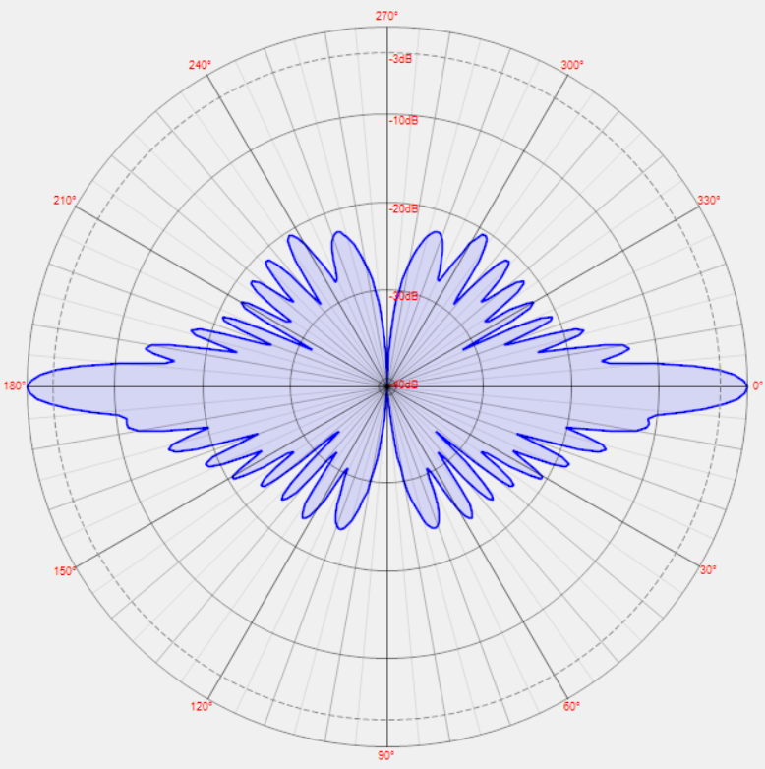

Standard Elevation Pattern

